TC-CMS-003
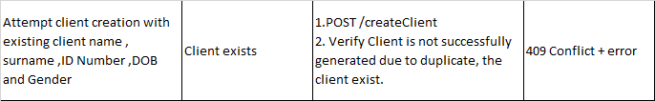
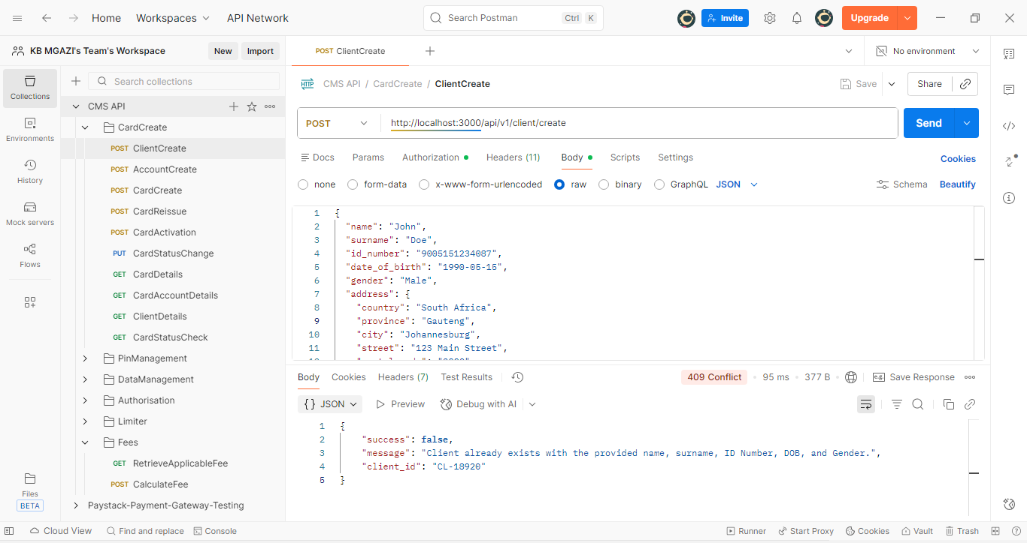
Request:
{
"name": "John",
"surname": "Doe",
"id_number": "9005151234087",
"date_of_birth": "1990-05-15",
"gender": "Male",
"address": {
"country": "South Africa",
"province": "Gauteng",
"city": "Johannesburg",
"street": "123 Main Street",
"postal_code": "2000"
},
"work_address": {
"country": "South Africa",
"province": "Gauteng",
"city": "Johannesburg",
"street": "456 Business Road",
"postal_code": "2001"
},
"income": 45000,
"tax_number": "1234567890"
}
Response:
{
"success": false,
"message": "Client already exists with the provided name, surname, ID Number, DOB, and Gender.",
"client_id": "CL-18920"
}

Client Already Exist
